|  |
| --- |
| **SOLVING BIGDATA PROBLEM AND HADOOP & HADOOP FRAMEWORK**      ASSIGNMENT 1.2  Submitted By  PRAVEEN PHILIP SANTHOSH |

1. **pwd** -- The **pwd** command writes to standard output the full path name of one’s current directory (from the root directory). All directories are separated by a / (slash). The root directory is represented by the first /, and the last directory named is one’s current directory.

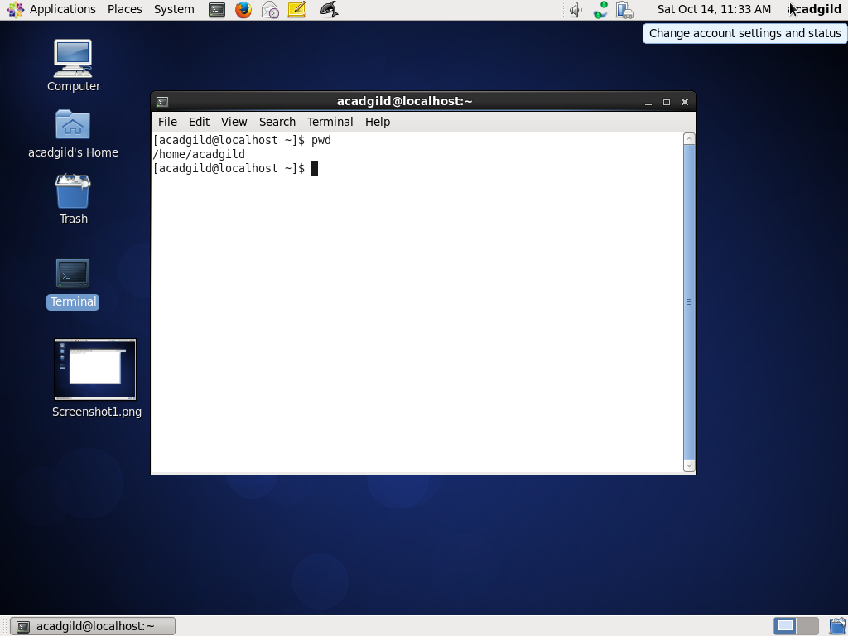

1. **Vi** -- Vi is a command line text editor. he command line is quite a different environment compared to GUI. It's a single window with text input and output only.

There are two modes in Vi. **Insert** (or Input) mode and **Edit** mode. In input mode you may input or enter content into the file. In edit mode you can move around the file, perform actions such as deleting, copying, search and replace, saving etc

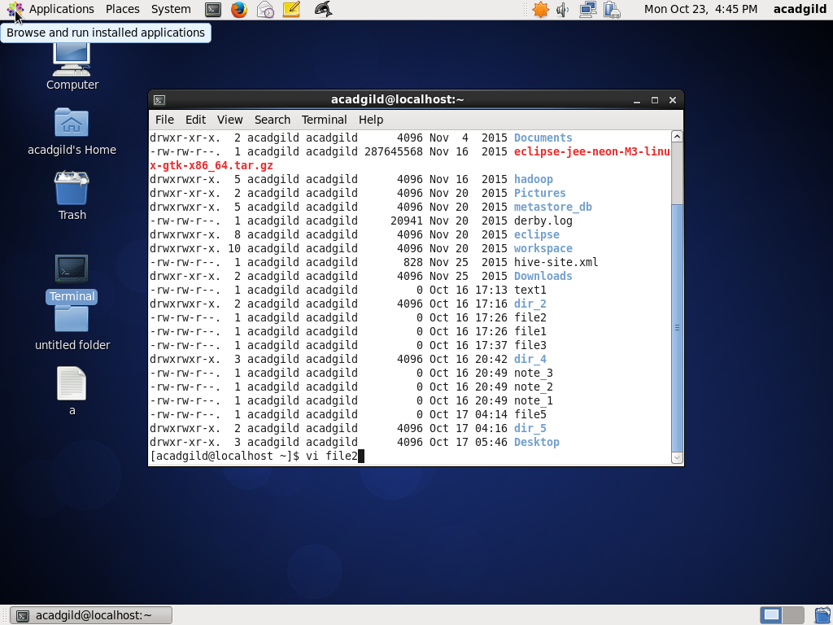

Vi continued……

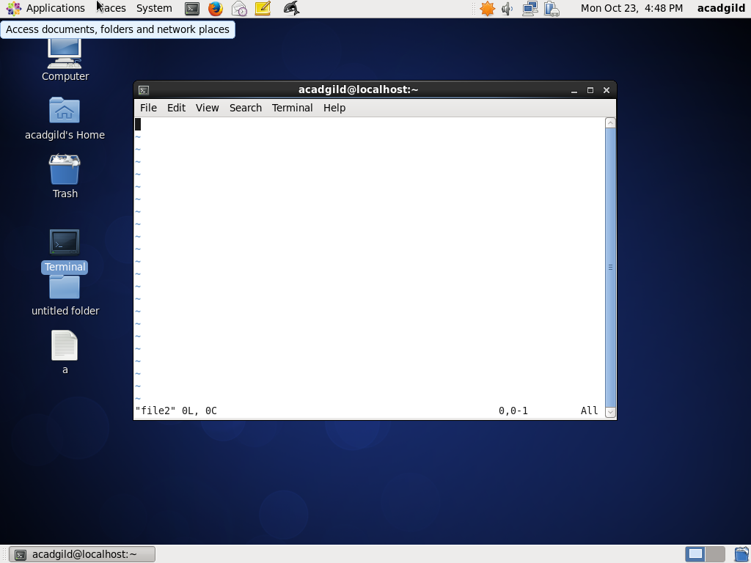

VI Continued……….

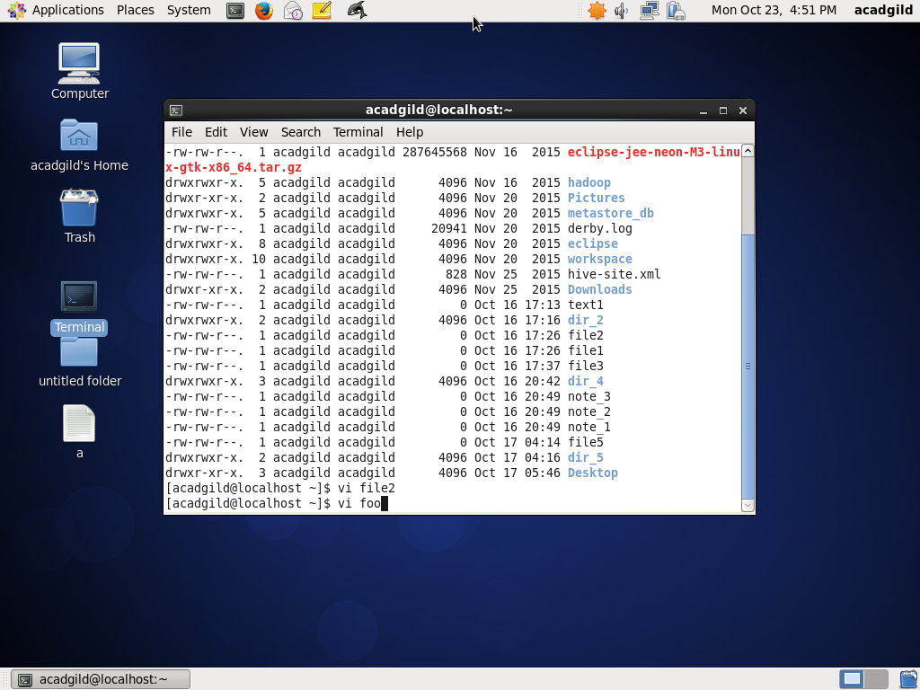

Vi Continued……..

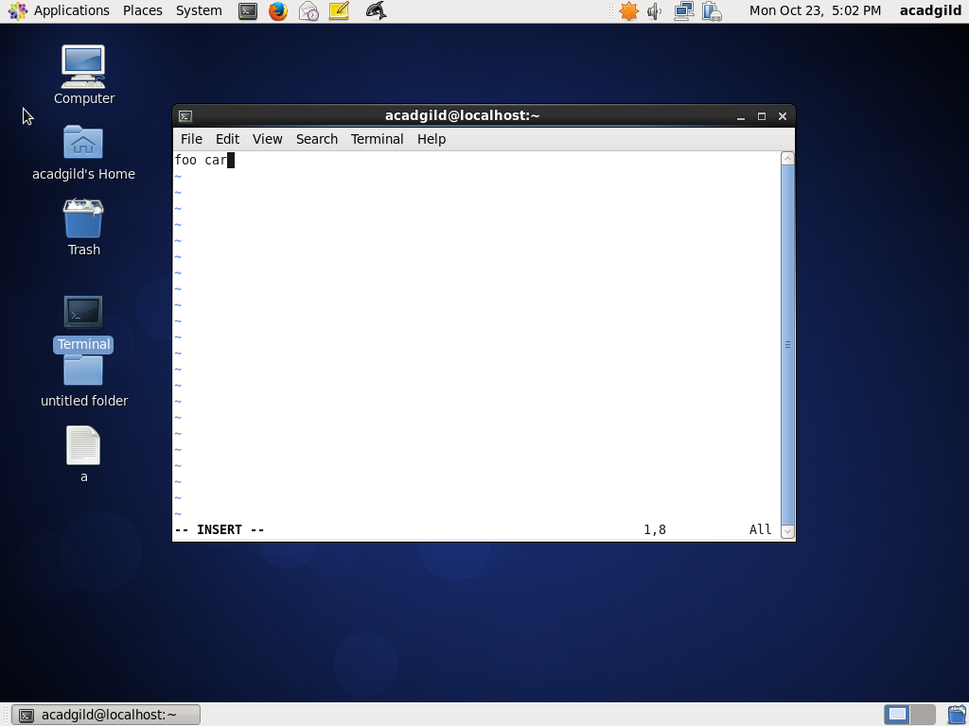

Vi continued……

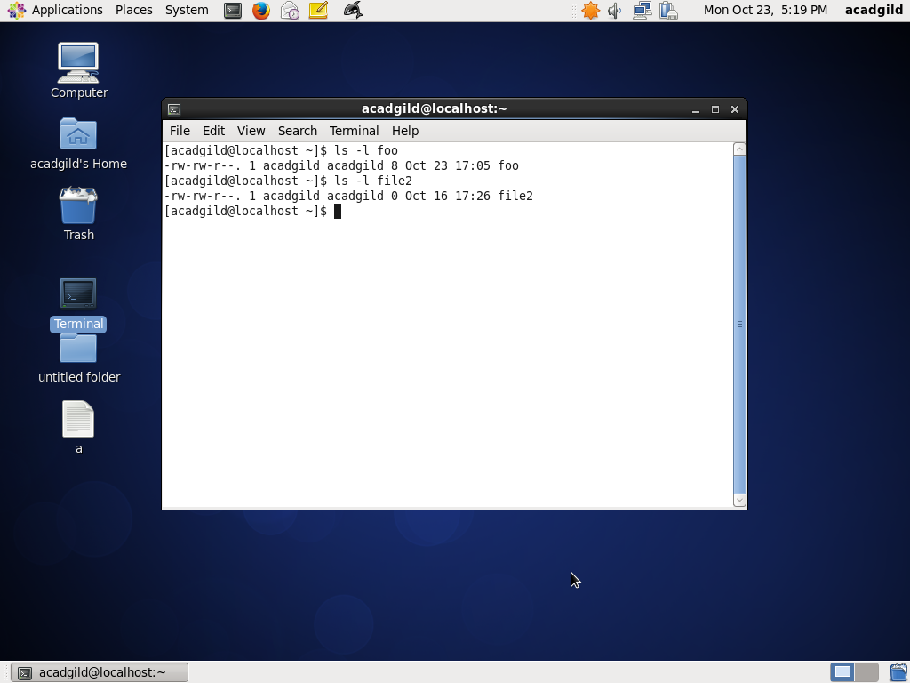

Vi continued……

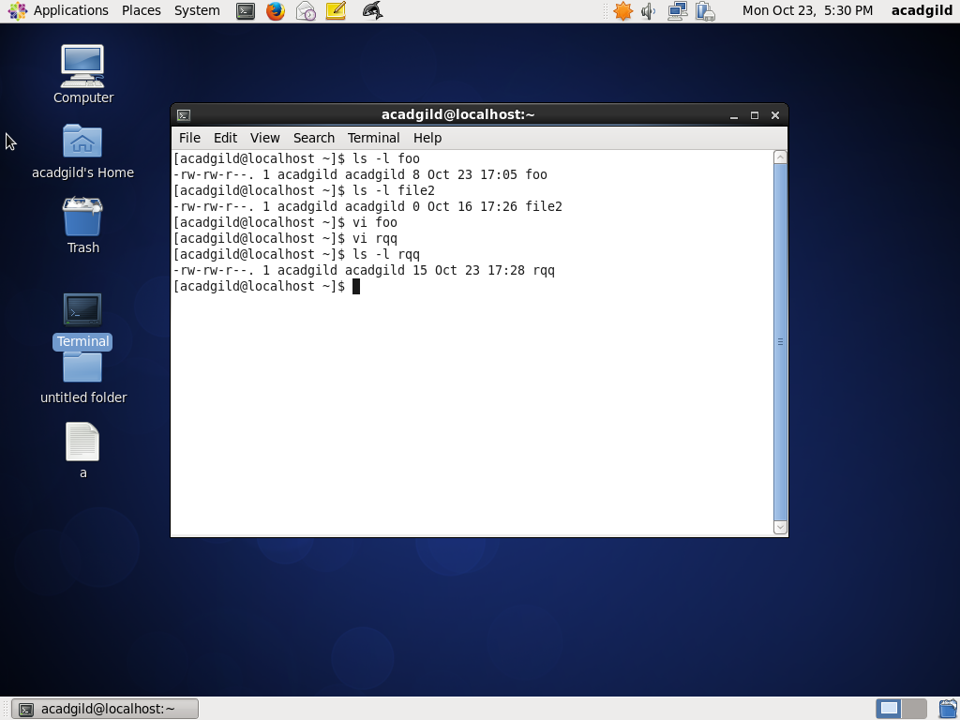

3.**Touch:** Command is used to change file time stamps. We can access and modify file time stamp to the current time stamp

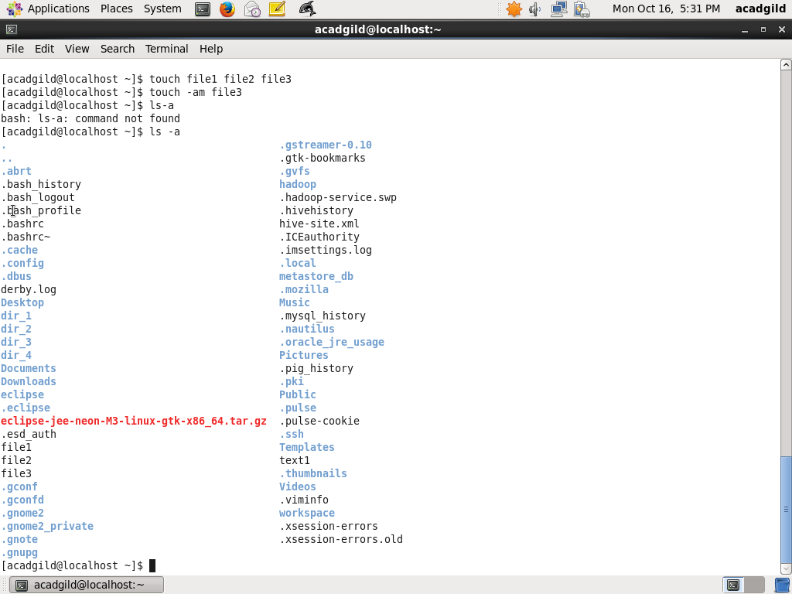

Touch Continued……..

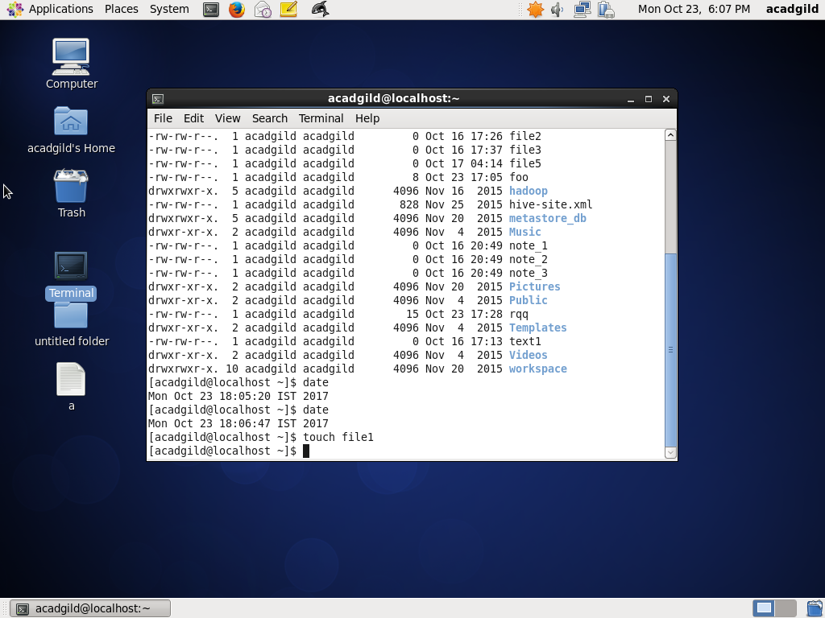

Touch continued………

**Here please note that the file 1 access time is 18:04**

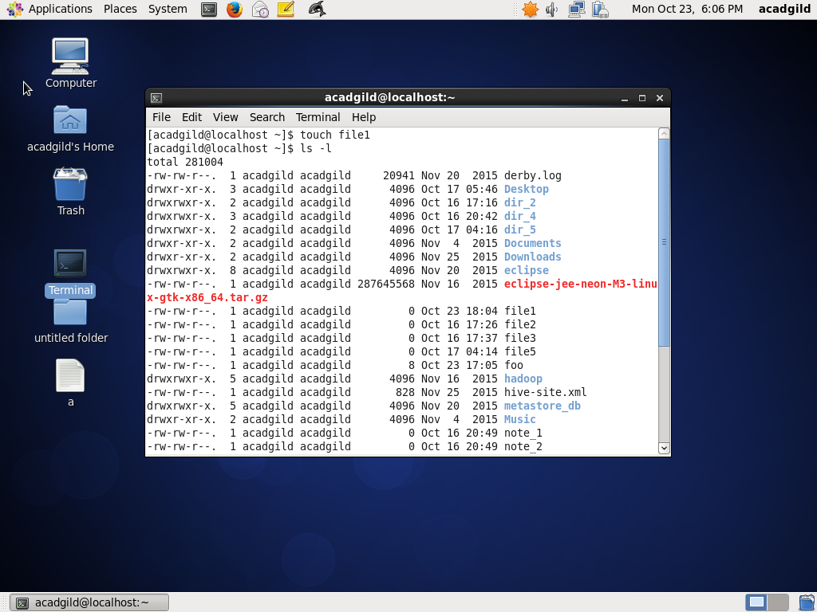

Touch Continued……..

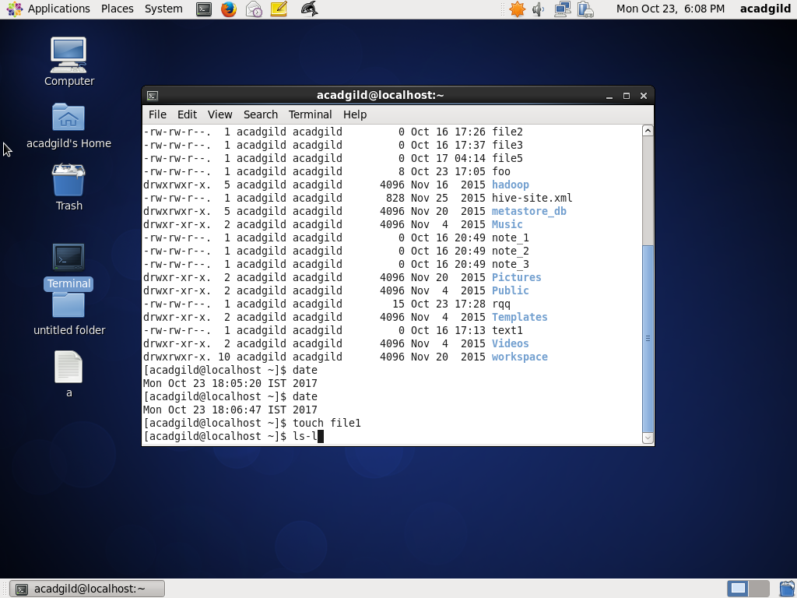

Touch continued…………

**Note : here see that file 1 access time has changed to 18:07 from 18:04**

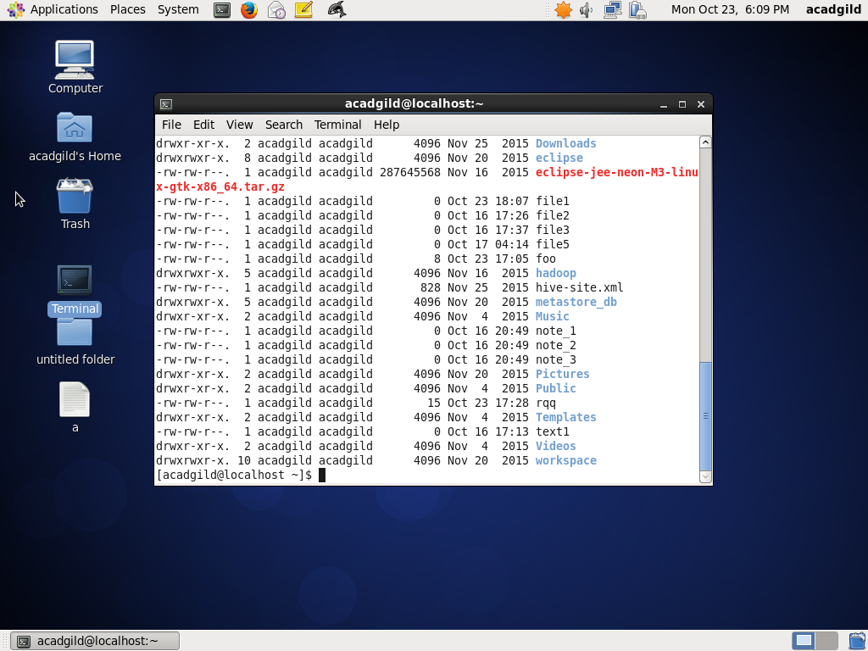

4.**Mkdir** : The mkdir command is used to create new directories. mkdir has the following syntax:

Mkdir [option ] directory_names

directory_name is the name of any directory that the user is asking mkdir to create. Any number of directories can be created simultaneously.

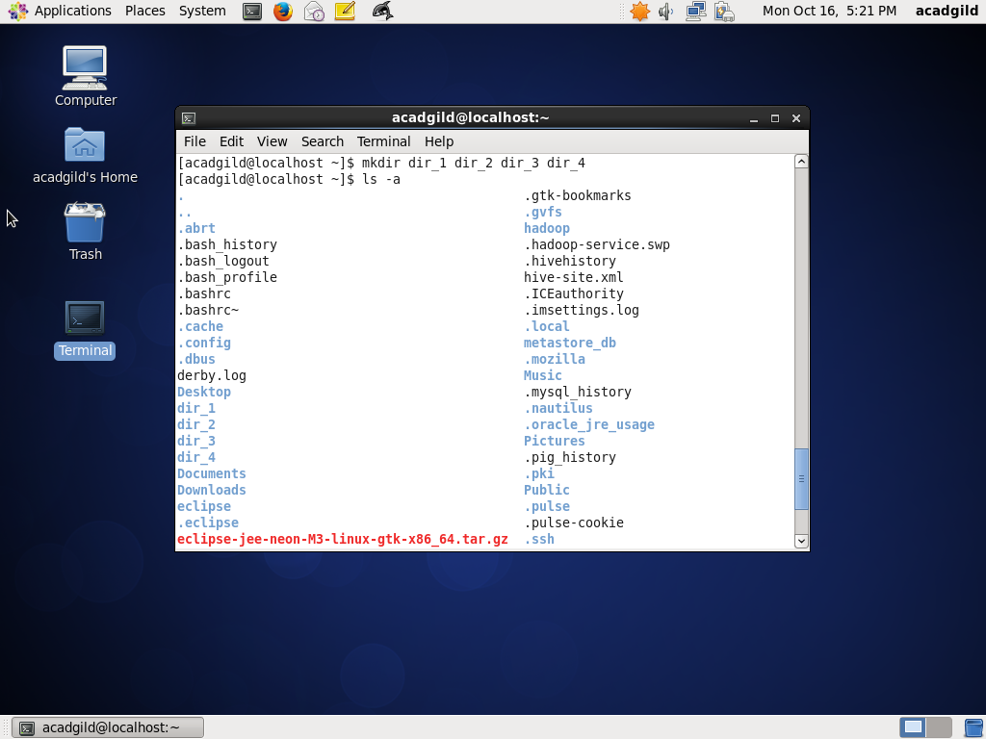

5.**Rm** : The rm (i.e., remove) command is used to delete files and directories .The general syntax for rm is: rm [options] [-r directories] filenames.The items in square brackets are optional. When used just with the names of one or more files, rm deletes all those files without requiring confirmation by the user**.** In the screenshot below  **Command rm -i file_name prompts the user if the file has to be removed**

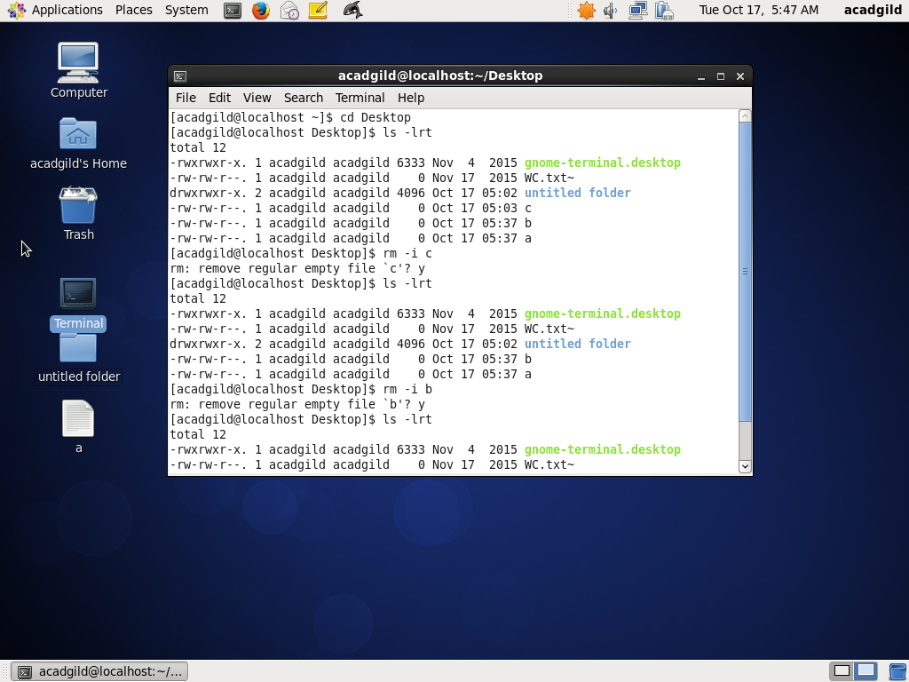

6. **ls** - *ls* is a linux shell command that lists directory contents of files and directories

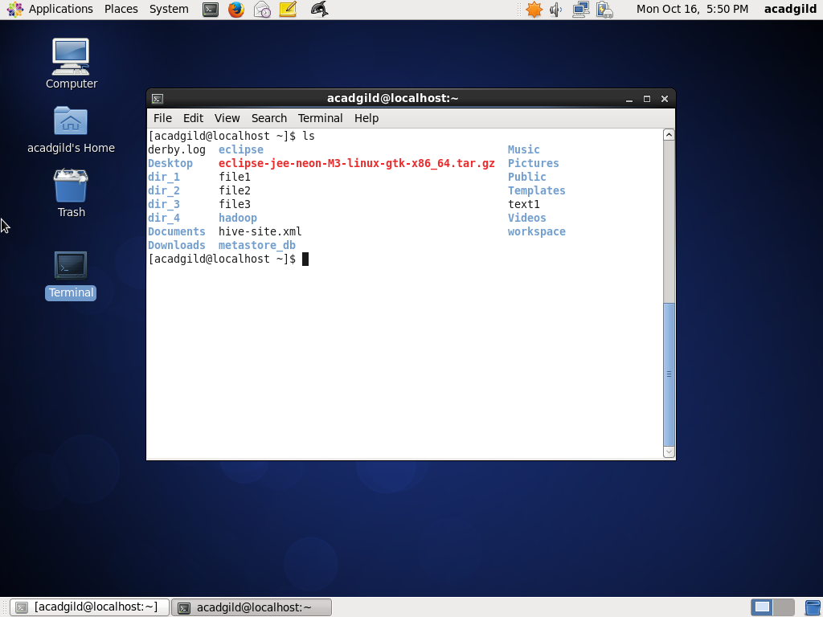

7. **Echo** - echo command is built in shell command , which used to display the value of a variable or print a line of text.

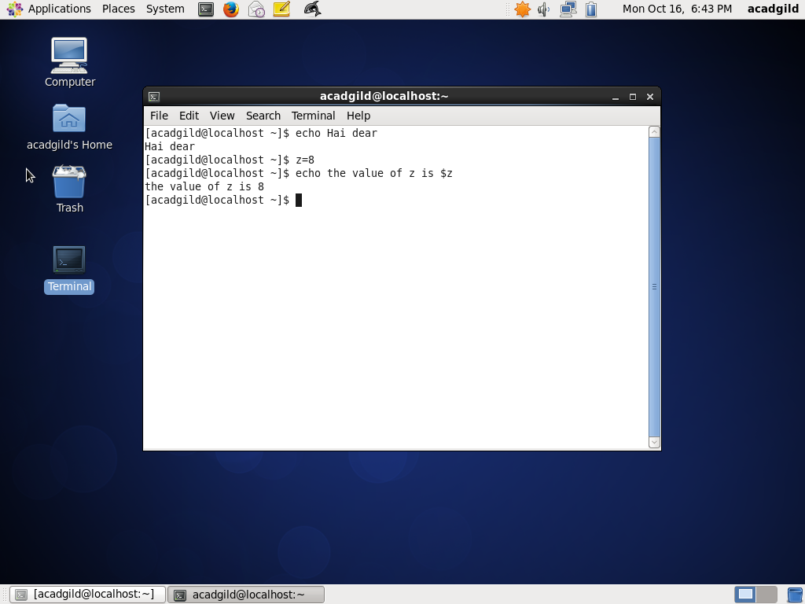

8. **Cat** (short for concatenate) has three related functions with regard to text files: displaying them, combining copies of them and creating new ones.

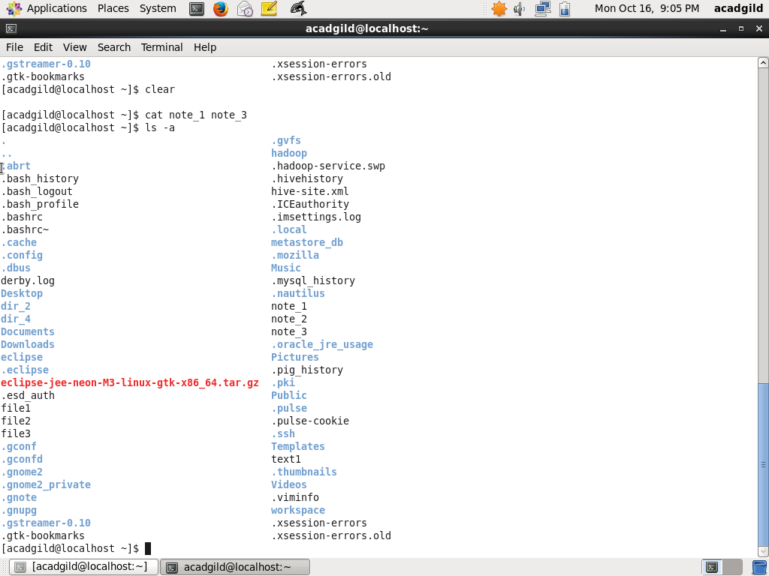

Cat Continued…….

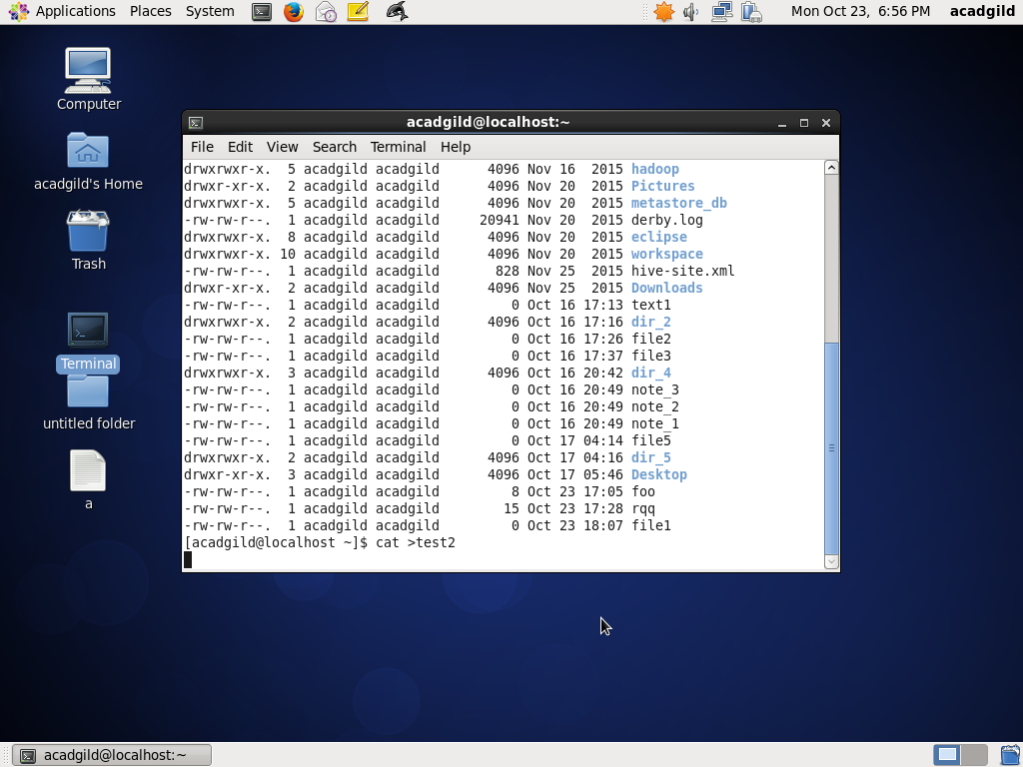

Cat continued ……….

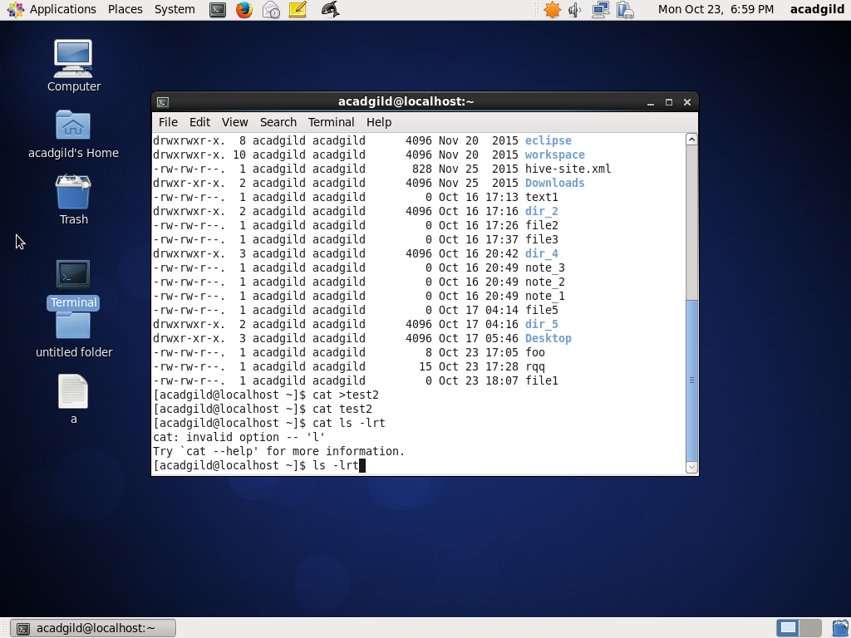

Cat Continued….

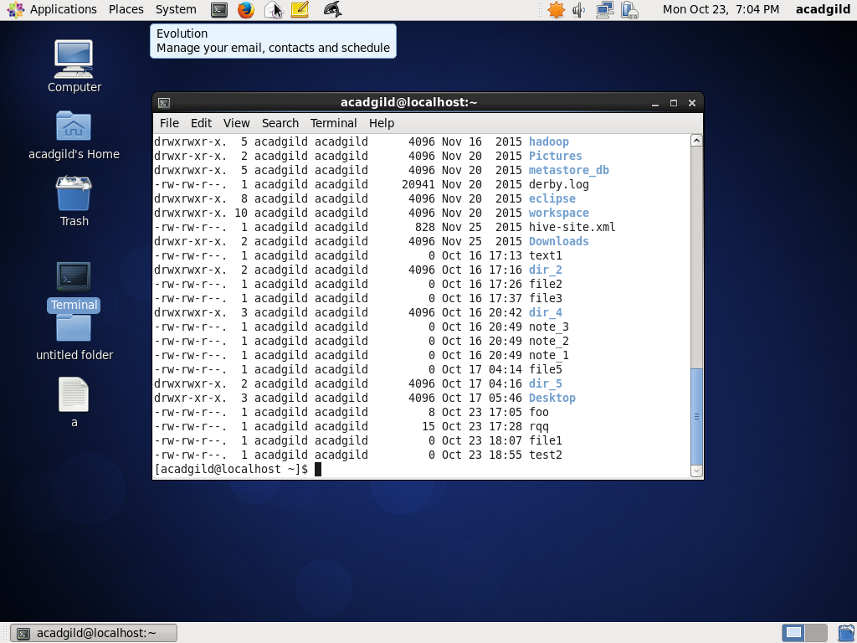

9. who: - Displays who is logged on to the system.

The who command prints information about all users who are currently logged in.

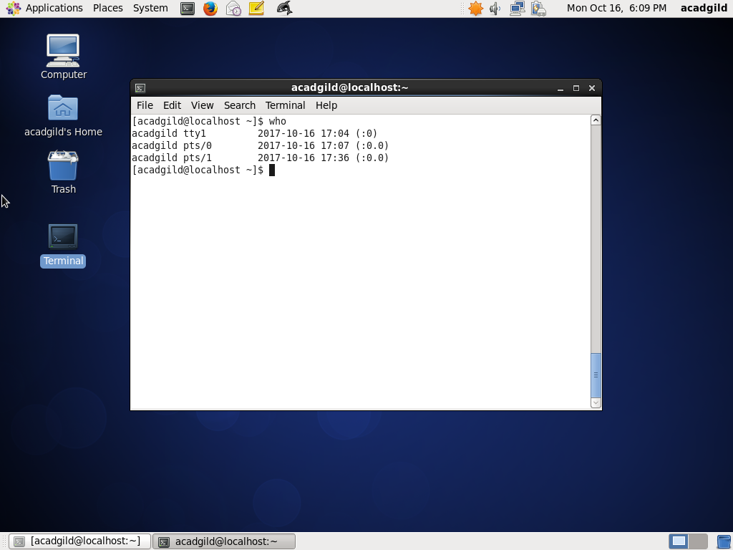

10.cd : The cd command, which stands for "change directory", changes the shell's current working directory.

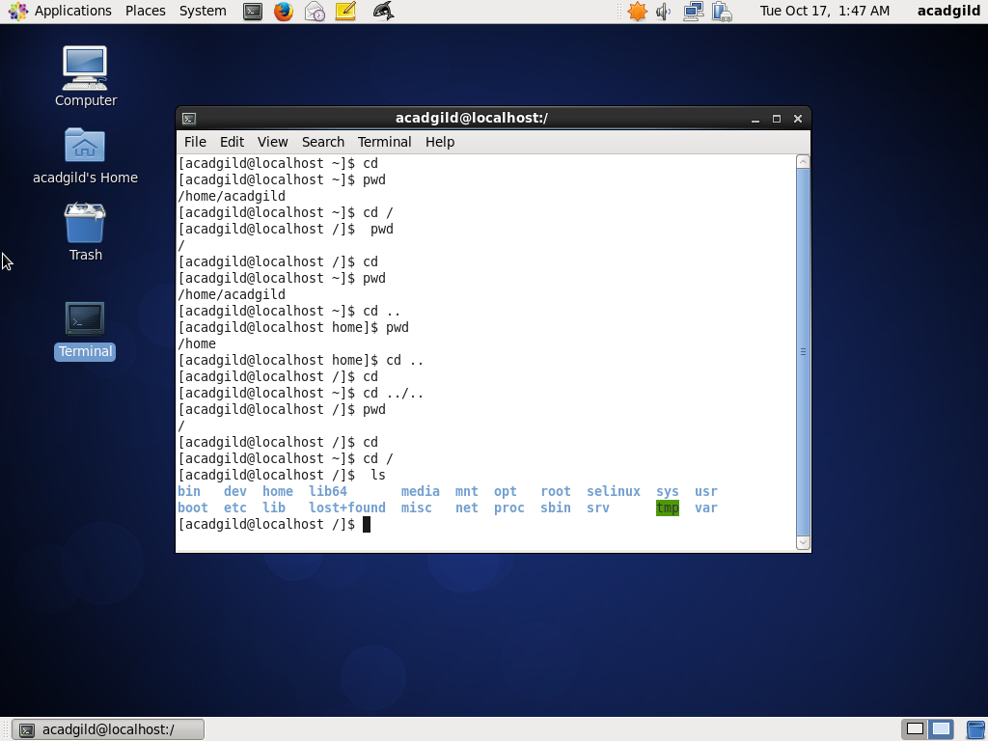

11.date : displays the current date and time

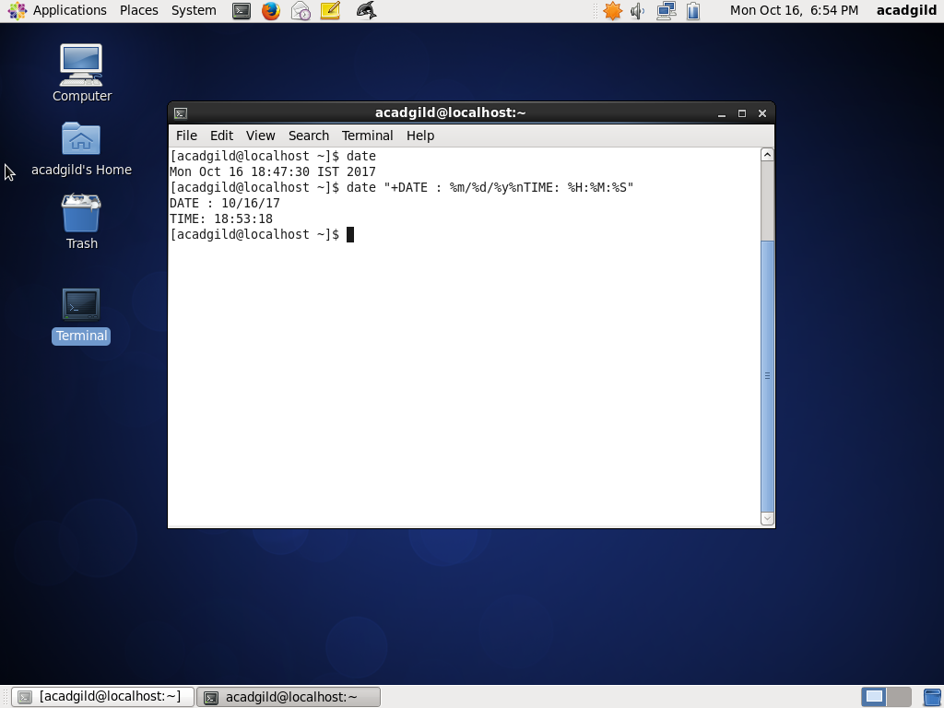

12 . cal – calendar –displays calendar

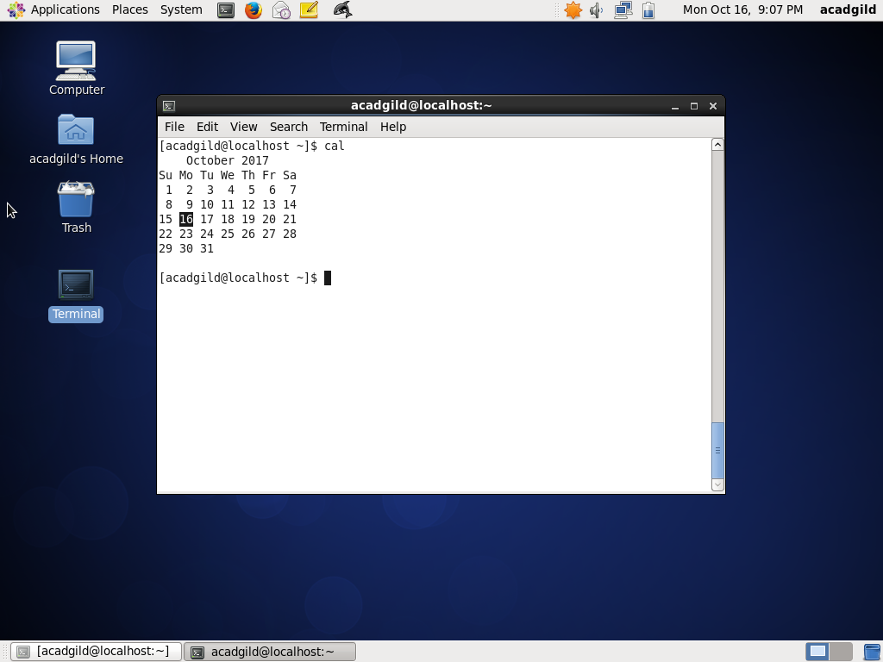

13. mv : The mv command moves files and directories from one directory to another or renames a file or directory . The mv command can overwrite many existing files unless you specify the -i flag. The -i flag prompts you to confirm before it overwrites a file

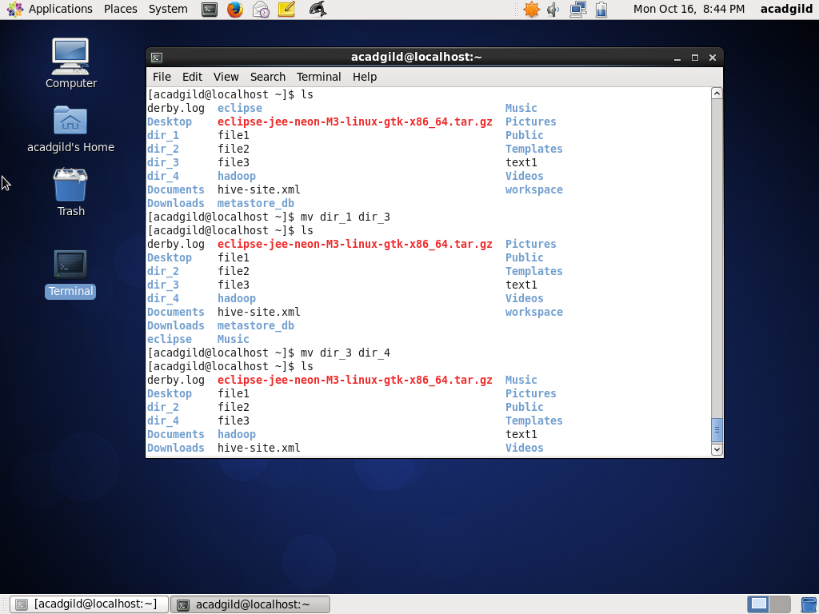

14.**cp :** The cp command copies the source file specified by the SourceFile parameter to the destination file specified by the TargetFile parameter. If the target file exists, cp overwrites the contents, but the mode, owner, and group associated with it are not changed. The last access time of the SourceFile and the last modification time of the TargetFile are set to the time the copy was done.

-i command is used so that the copy is not done automatically but the user is asked for reconfirmation if the file or directory should be overwritten.

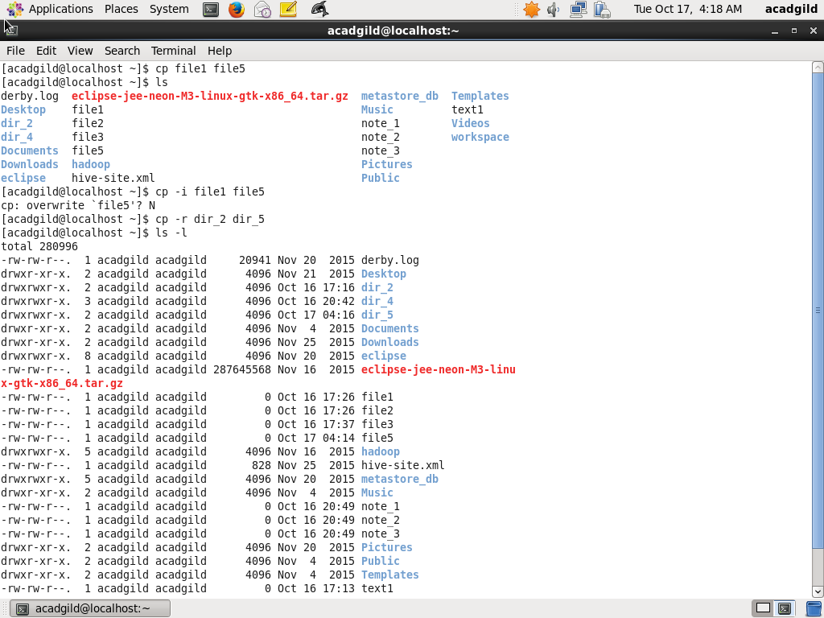

15. **which**: Command Locates a program file, including aliases and paths.

The **which** command takes a list of program names and looks for the files that run when these names are given as commands

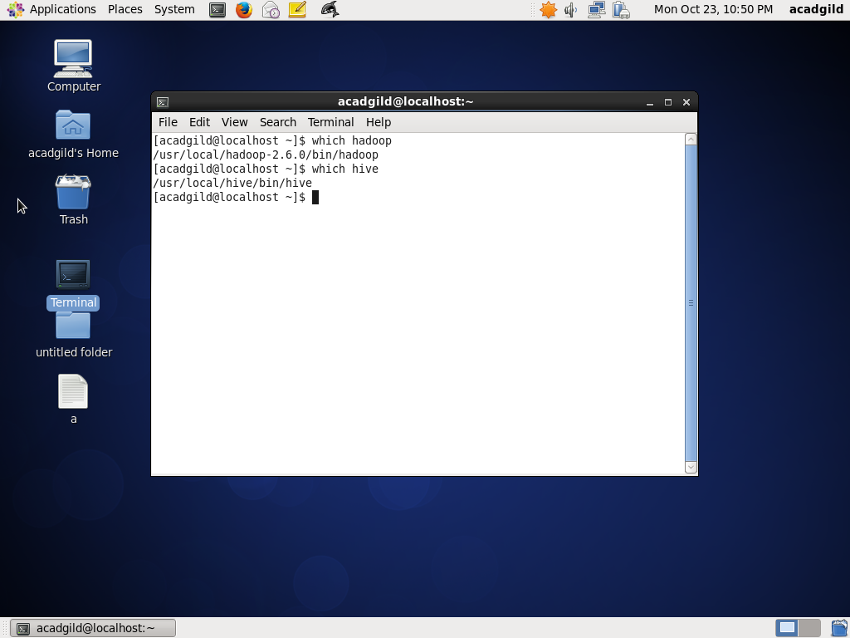

Which continued ………

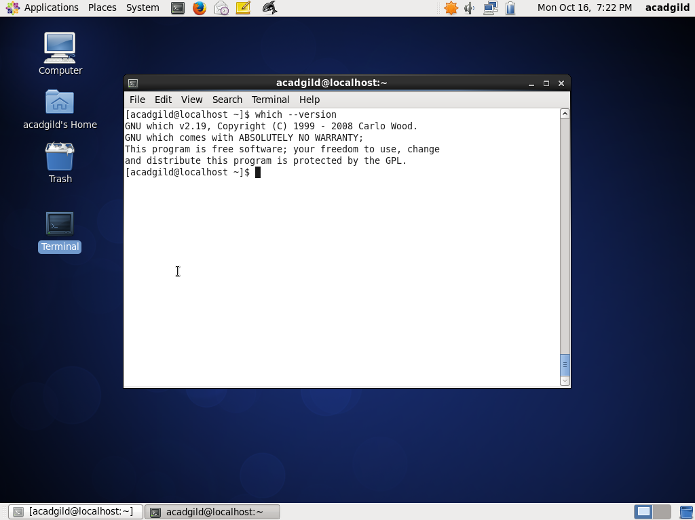

Which command: when searched file is not found .

